

American International University-Bangladesh (AIUB)

**Department of Computer Science  
Faculty of Science &Technology (FST)  
Fall 20-21**

**Introduction to Database**

**Section: K  
Group No: 7**

**Car Ride Management System**

An Introduction to Database project submitted

By

|  |  |  |
| --- | --- | --- |
| Serial No. | Student Name | Student ID |
| 23 | AFTAB, RAKIN SAD | 20-41991-1 |

**ER DIAGRAM**

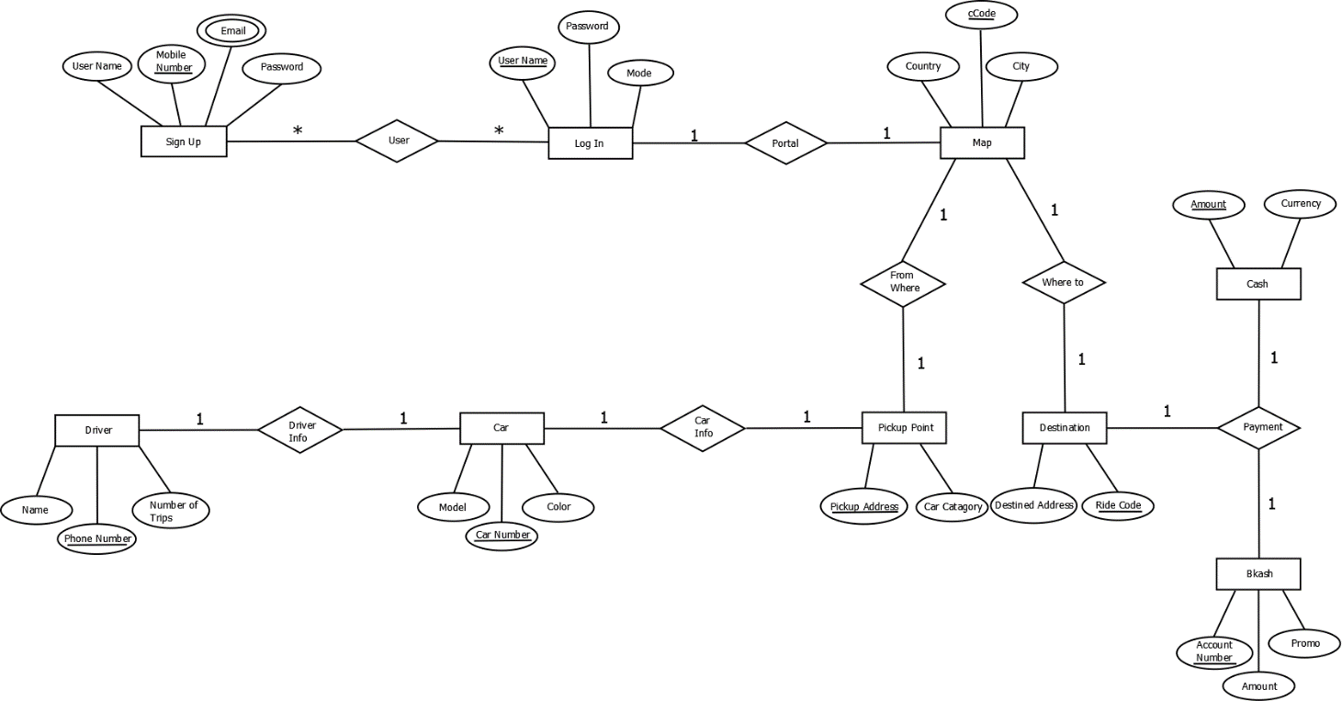

**Description**

1. Mr. X wants to go to Uttara from Dhanmondi but he can't find any transport. Suddenly he remembered that he had downloaded an app from play store which is a car ride app. In the app Mr. X has to Sign up providing his Username, E-mail, Password & Mobile Number. Maximum one sign up from one mobile number can be possible.
2. Next, he has to Log in as a user with his E-mail and unique Password. Many sign ups and many logins are possible.
3. After logging in, he will be redirected to a Portal where Map selection will be done. In the map there's all available countries and cities of the world where this car ride service is available. And he has to select the country and city he is in. One log in can have one country and city selection. An auto cCode will be generated for specification.
4. He can select the pickup point where he has to select his pickup address and car category such as premium or normal.
5. He can select his destined address from destination selection and will get a unique ride code. From one map selection to one pickup point and one destination selection can be done.
6. One payment method can be selected among cash and bkash from destination selection. For cash there will be a unique amount and currency. And for bkash a unique account number, amount and a promo code for discount if available.
7. After selecting those he will be connected to his nearest Car. Only car from for one ride will be found and car’s info such as model, unique car number and color will be available for him to see.
8. For that particular car the info of the driver of that car will be available to see. The information will be the driver's name, unique phone number and his total number of trips.

“Green Color” means Primary Key

“Red color” means Foreign key

**User** –(Phone, UserName, Email, Password, UserName, Password, Version)

**1NF:** Email is a multivalued attribute.

**2NF:** Phone, UserName, Email, Password

UserName, Password, Version

**3NF:** No transitive dependency

Phone, UserName, Email, Password

UserName, Password, Version

Tables for **User** -

1. Phone, UserName, Password
2. UserName, Password, Version
3. U_id, UserName, Phone – Composite PK
4. Phone, Email

* **Portal** – (UserName, Password, Version, Country, cCode, City)

**1NF:** No multivalued attribute.

**2NF:** UserName, Password, Version

cCode, Country, City

**3NF:** No transitive dependency

UserName, Password, Version

cCode, Country, City

Tables for **Portal** –

1. UserName, Password, Version
2. cCode, Country, City, UserName

* **From Where** – (cCode, Country, City, PickupAddress, CarCatagory)

**1NF:** No multivalued attribute.

**2NF:** cCode, Country, City

PickupAddress, CarCatagory

**3NF:** No transitive dependency

cCode, Country, City

PickupAddress, CarCatagory

Tables for **From Where** –

1. PickupAddress, CarCatagory, cCode
2. cCode, Country, City

* **Where to** – (cCode, Country, City, RideCode, DestinedAddress)

**1NF:** No multivalued attribute.

**2NF:** cCode, Country, City

RideCode, DestinedAddress

**3NF:** No transitive dependency

cCode, Country, City

RideCode, DestinedAddress

Tables for **Where to** –

1. RideCode, DestinedAddress, cCode
2. cCode, Country, City

* **Car Info** – (PickupAddress, CarCatagory, CarNumber, Model, Color)

**1NF:** No multivalued attribute.

**2NF:** PickupAddress, CarCatagory

CarNumber, Model, Color

**3NF:** No transitive dependency

PickupAddress, CarCatagory

CarNumber, Model, Color

Tables for **Car Info** –

1. CarNumber, Model, Colour, PickupAddress
2. PickupAddress, CarCatagory

* **Payment** – (RideCode, DestinedAddress, Amount, Currency, AccountNumber, Amount, Promo)

**1NF:** No multivalued attribute.

**2NF:** RideCode, DestinedAddress

Amount, Currency

AccountNumber, Amount, Promo

**3NF:** No transitive dependency

RideCode, DestinedAddress

Amount, Currency

AccountNumber, Amount, Promo

Tables for **Payment** –

1. RideCode, DestinedAddress
2. Amount, Currency, RideCode
3. AccountNumber, Amount, Promo, RideCode

* **Driver Info** – (CarNumber, Model, Colour, DriverPhn, DriverName, TripsNum)

**1NF:** No multivalued attribute.

**2NF:** CarNumber, Model, Colour

DriverPhn, DriverName, TripsNum

**3NF:** No transitive dependency

CarNumber, Model, Colour

DriverPhn, DriverName, TripsNum

Tables for **Driver Info** –

1. DriverPhn, DriverName, TripsNum, CarNumber
2. CarNumber, Model, Colour

**Final Table**

1. Phone, UserName, Password
2. UserName, Password, Version
3. U_id, UserName, Phone – Composite PK
4. Phone, Email
5. cCode, Country, City, UserName
6. PickupAddress, CarCatagory, cCode
7. RideCode, DestinedAddress, cCode
8. CarNumber, Model, Colour, PickupAddress
9. Amount, Currency, RideCode
10. AccountNumber, Amount, Promo, RideCode
11. DriverPhn, DriverName, TripsNum, CarNumber
12. **Table Name – Sign Up**

**Screenshot – desc Sign_up**

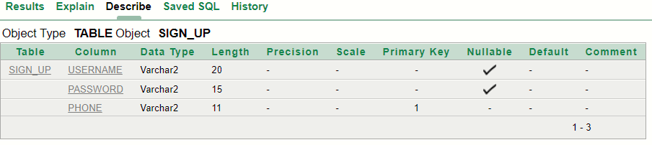

**Screenshot – Displaying (Insertion)**

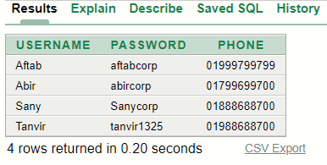

1. **Table Name – Log_in**

**Screenshot – desc Log_in**

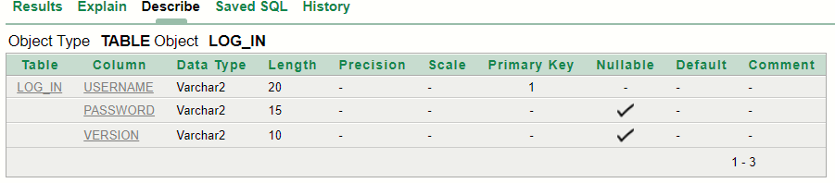

**Screenshot – Displaying (Insertion)**

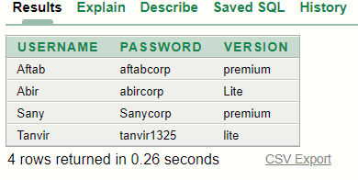

1. **Table Name – User_info**

**Screenshot – desc User_info**

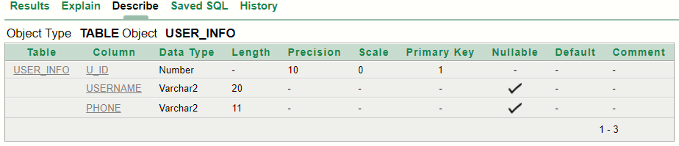

**Screenshot – CONSTRAINTS (V1 & V2)**

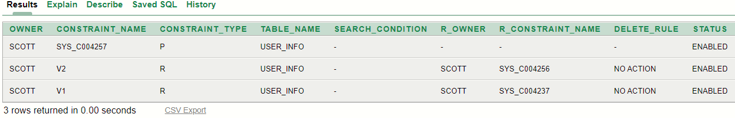

**Screenshot – SEQUENCE (ID_SQ)**



**Screenshot – Displaying (Insertion)**

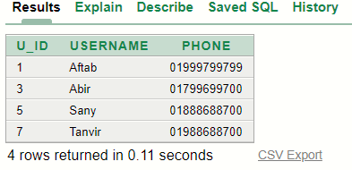

1. **Table Name – Personal_info_user**

**Screenshot – desc Personal_info_user**

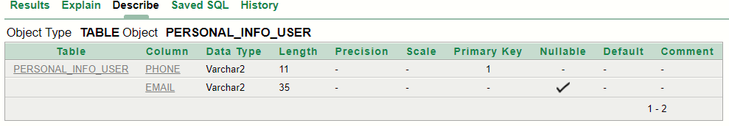

**Screenshot – Displaying (Insertion)**

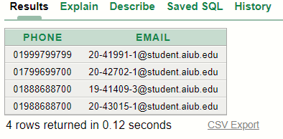

1. **Table Name – User_Loc**

**Screenshot – desc User_Loc**

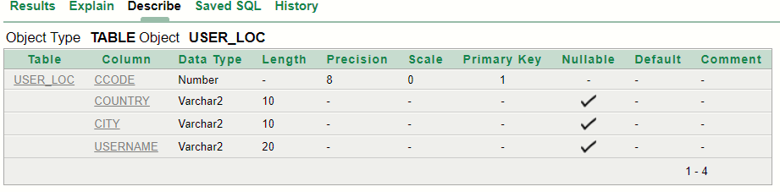

**Screenshot – CONSTRAINTS (V3)**

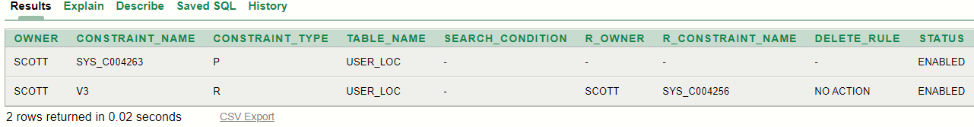

**Screenshot – SEQUENCE (CC_SQ)**

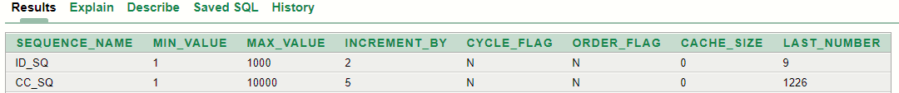

**Screenshot – Displaying (Insertion)**

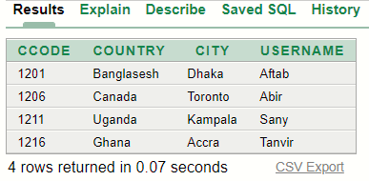

1. **Table Name – PickUp**

**Screenshot – desc PickUp**

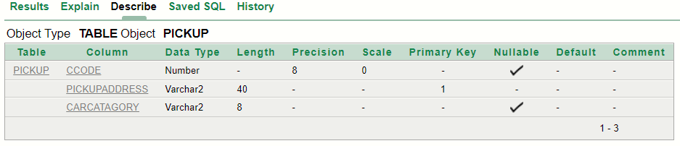

**Screenshot – CONSTRAINTS (V5)**

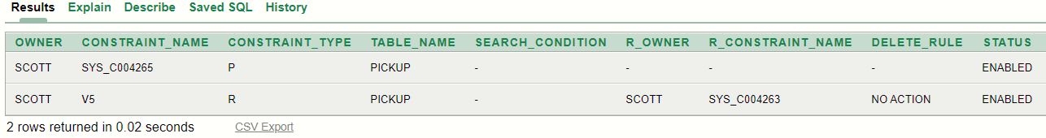

**Screenshot – Displaying (Insertion)**

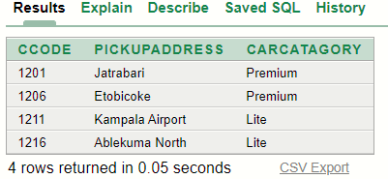

1. **Table Name – Destination**

**Screenshot – desc Destination**

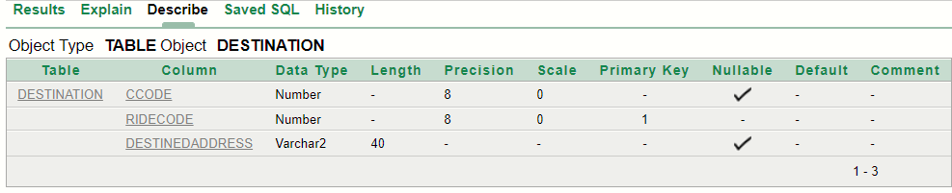

**Screenshot – CONSTRAINTS (V6)**

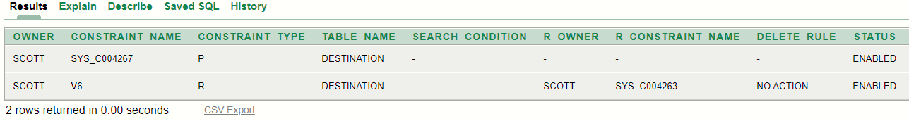

**Screenshot – SEQUENCE (RC_SQ)**

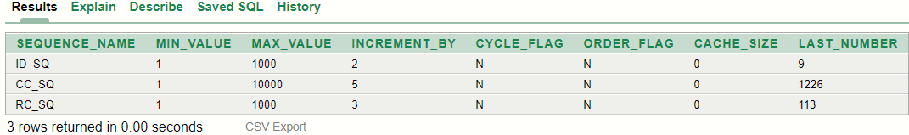

**Screenshot – Displaying (Insertion)**

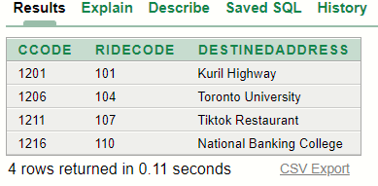

1. **Table Name – Car_info**

**Screenshot – desc Car_info**

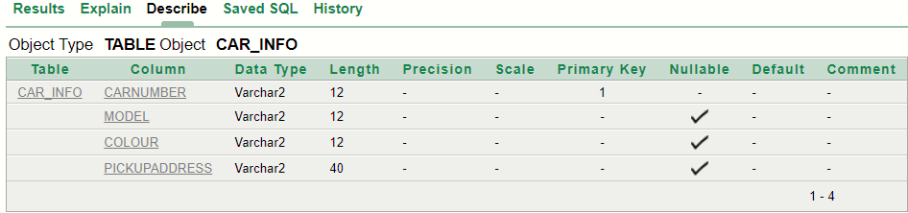

**Screenshot – CONSTRAINTS (V7)**

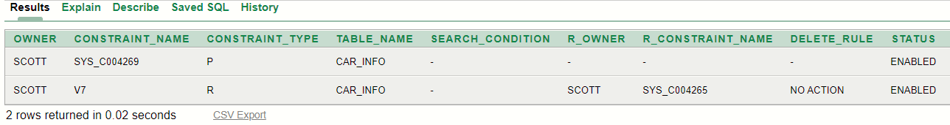

**Screenshot – Displaying (Insertion)**

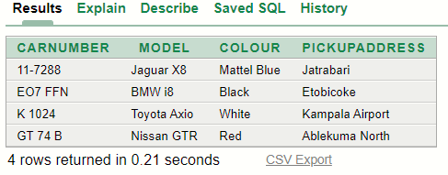

1. **Table Name – Cash**

**Screenshot – desc Cash**

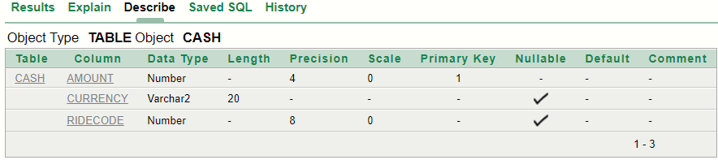

**Screenshot – CONSTRAINTS (V8)**

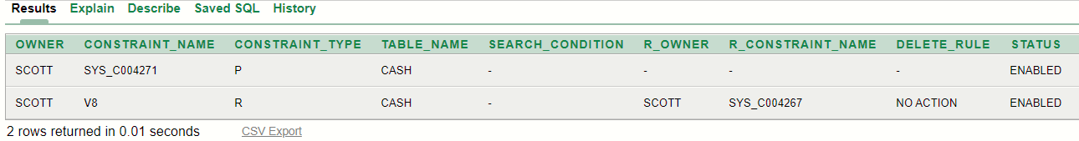

**Screenshot – Displaying (Insertion)**

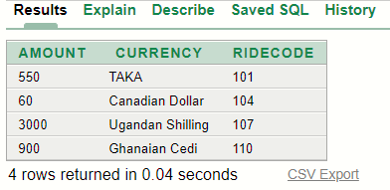

1. **Table Name – Online_Pay**

**Screenshot – desc Online_Pay**

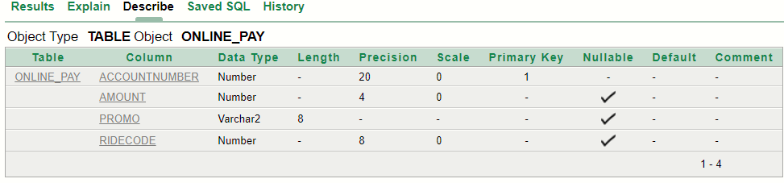

**Screenshot – CONSTRAINTS (V9)**

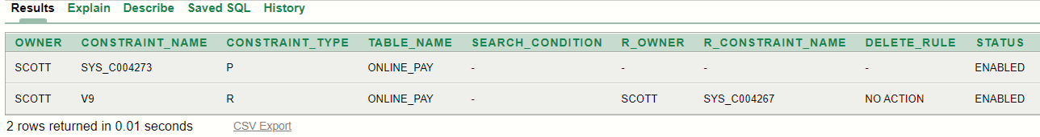

**Screenshot – Displaying (Insertion)**

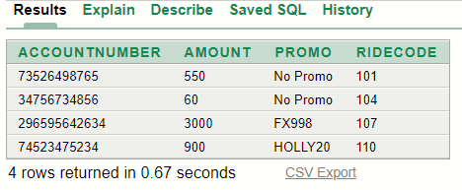

1. **Table Name – Driver_info**

**Screenshot – desc Driver_info**

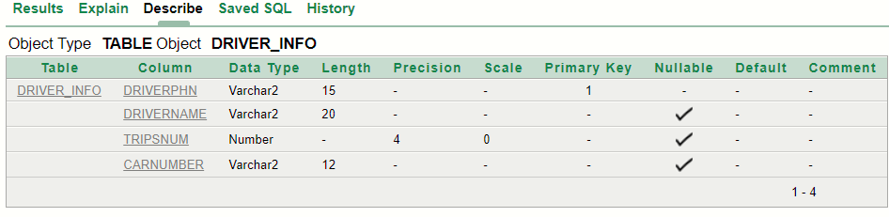

**Screenshot – CONSTRAINTS (V10)**

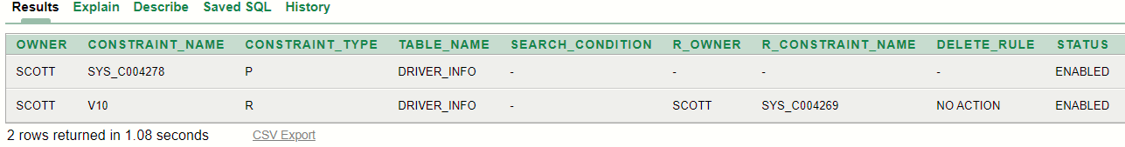

**Screenshot – Displaying (Insertion)**

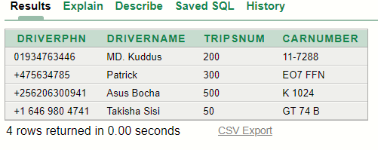

**Questions**

1. Display the username tagged as User Name whose phone number is 01888688700 from sign_up table.
2. Display user name and email of the user whose 3rd character of the phone number is 7.
3. Display the total number of rows where the version is premium from the Log_in table.
4. Display all the details from the User_Loc table whose country code is greater than Aftab’s country code.
5. Display username and pick up address of users who has chosen premium car category.
6. Alter the RC_SQ sequence increment by 5 max value should be 2000.
7. Create and display a read only view named car from Driver_info table with driver’s phone number, name & car number where the number of trips is greater than 100.
8. Display the user id and user name as “5 is the user Id of Sany” in the descending order of user id, where the id is between 1 to 5 and name the column as “User ID Information”.
9. Display the driver name, car number & model where there is 10 in the middle of the car number.
10. Display amount, currency, account number and promo code for the user who paid the maximum amount. (currency value is negatable)